NMAM INSTITUTE OF TECHNOLOGY, NITTE
Department of Information Science and Engineering

OPERATING SYSTEMS PROGRAMMING ASSIGNMENT REPORT
AI-Assisted Synchronization Algorithms with Program-Generated HTML Simulation
Readers-Writers Problem and Dining Philosophers Problem
(Semaphore-based and Monitor-based implementations in Java)

SUBMITTED BY

Name | Krithin Salian
Registration / USN | NNM24IS110
Course | Operating Systems
GitHub Repository | https://github.com/Krithin76/OS-Task2.git

SUBMITTED TO
Dr Jason Elroy Martis
Associate Professor
Dept. of Information Science and Engineering, Nitte

1. Dining Philosophers Problem - 4 Philosophers - Semaphore Based

Problem Statement: The implementation of the Dining Philosophers problem for four philosophers using semaphores. It should be observed here that the implementation should be synchronized use of the forks and the concern of deadlock and starvation.

Objective:To understand synchronization using semaphores and allocate forks for four philosophers taking into consideration the problems of deadlock and starvation.

Working:
The Dining Philosophers Problem with four philosophers using semaphores is a problem related to the Operating System. Four philosophers sit at a round table having four forks, where each philosopher keeps on switching between thinking and eating. In order to eat, the philosopher requires two forks, that is, the left and the right fork. A binary semaphore named mutex = 1 is used for protecting the states of the philosophers, and there are four different semaphores namely, S[4] = 0 which determines the conditions when each philosopher will be allowed to eat. When a philosopher gets hungry, then he will execute the procedure of wait(mutex) and his state will get changed to HUNGRY. Then the test() procedure is executed in order to check whether the left and right neighbor is eating. If neither is eating, then the state of the philosopher gets changed to EATING and then the signal(S[i]) will allow him to do so. After that philosopher gets finished from the meal, he executes put_forks(), changes state to THINKING and determines whether any neighbor is allowed to eat or not.

2. Dining Philosophers Problem - 4 Philosophers - Monitor Based

Problem Statement:The aim here is to implement the Dining Philosophers problem with four philosophers using monitors or locks and condition variables. The program that will be implemented will deal with the use of forks, coordination between the status of the philosophers, and avoiding conflicts.

Objective:To comprehend the process of synchronization of concurrent processes using monitor based techniques and managing shared resources without deadlock, taking the example of the “dining philosopher’s problem.”

Working:
The implementation of the problem of four dining philosophers through the use of a monitor involves creating four philosopher threads, with each thread simulating a philosopher seated at a round table surrounded by four forks in between adjacent philosophers. At the beginning, all the philosophers are in the THINKING state. However, when a philosopher intends to have a meal, the philosopher's state changes to HUNGRY and the philosopher invokes takeForks() method to obtain permission for the forks' usage. The monitor handles shared resources access through the synchronization of Java methods which allows only one thread to modify philosophers' states at a time. The test() method is used to verify whether the philosopher's left and right neighbors are not in the EATING state. In case both neighbors are not eating, the philosopher's state changes to EATING state and starts eating. In other cases, the philosopher uses the wait() method and waits until he/she obtains permission to eat. Once the philosopher finishes the food, the philosopher invokes putForks() method, changes the state to THINKING state and releases the forks. The monitor checks whether the philosopher's left or right neighbor has permission to eat and uses notifyAll() method to awaken threads for re-checking their conditions. This cycle continues until philosophers think, become hungry, eat and release forks. Since neighboring philosophers cannot be in the EATING state simultaneously, mutual exclusion and absence of deadlock occurs.

3. Readers-Writers Problem - Semaphore Based

Problem Statement:A solution to Readers-Writers problem through the use of semaphores for synchronization of multiple readers and writers that have access to the same resource. It ensures data consistency, prevents concurrent access conflict and records change in state of system in HTML format.

Objective:A solution to Readers-Writers problem through the use of semaphores for synchronization of multiple readers and writers that have access to the same resource. It ensures data consistency, prevents concurrent access conflict and records change in state of system in HTML format.

Working:
The problem of the reader and writer is a classic problem in operating systems. This is the problem of synchronizing access to shared resources by more than one process or thread. In the problem, the reader accesses the shared resource, but does not write into it, while the writer updates the resource. The primary task of the problem is to provide simultaneous access of several readers to the shared resource, while providing exclusive access of one writer to the resource at a time. In case a writer writes the shared resource, no reader or any other writer can access the resource.At first, two semaphores are created – mutex and wrt. Mutex semaphore is used to protect the shared variable, i.e., the variable containing the number of readers who use the shared resource at a given moment in time. The wrt semaphore is used for controlling access to the shared resource in order to perform writing operations. These semaphores are set to the value of 1, which indicates their availability. They may be represented as Semaphore objects in Java.Once the reader desires to access the shared data, he/she obtains the mutex semaphore by calling the acquire() function. This avoids simultaneous modification of the readCount variable by other readers. The reader increases the readCount by one to show that a reader has joined the critical section. If the readCount is equal to one, this shows that the current reader is the first reader. Consequently, the first reader obtains the wrt semaphore to prevent any writer from accessing the shared data as long as readers are accessing it. Once the readCount variable has been incremented, the reader releases the mutex semaphore by calling the release() function. The reader does not need to access the shared data through the wrt semaphore since the first reader already controls the resource against the writers.For a writer to change the shared data, it tries to obtain the wrt semaphore. When there are no readers or writers accessing the shared data at the time, the writer is able to get the semaphore and proceed into the critical section. At this stage, the writer does not allow any other writer to access the critical section, while readers are unable to start reading since they too have to get the same semaphore. After getting the semaphore, the writer changes the data. Once done with changing the data, the writer releases the wrt semaphore to allow another reader or writer to access the shared data.

4. Readers-Writers Problem - Monitor Based

Problem Statement:Solution to the Readers-Writers problem using monitors, or any other solution that uses locks and condition variables.
Implementation: There has to be a control over access to the shared resources and coordination among readers and writers through this implementation.

Objective:Research on the synchronization of monitors using mutual exclusion and condition variables to coordinate readers and writers.

Working:
The Reader-Writers Problem Using Monitor in an operating system is a famous synchronization problem that manages access to shared data between more than one reader and more than one writer. The readers just read the shared data, while the writers make changes to the shared data. The primary aim is to ensure that more than one reader can read the shared data at the same time but that there is only one writer who accesses the shared data at any one point of time. While a writer is accessing the shared data, neither a reader nor another writer can access the shared data. A monitor is a way to achieve synchronization, which combines shared data, procedure, and synchronization mechanism. Monitors in Java can use synchronized, wait(), and notifyAll().At the beginning, a shared variable known as readCount is set to zero to count the number of active readers for the shared data. Also, there is a Boolean variable or something like that which is used to represent whether a writer is writing at the moment. The monitor manages the access to these shared variables in such a way that at one moment only one thread is allowed to execute the synchronized methods.

HTML Stimulation and screenshot:
1. Dining Philosopher Semaphore based
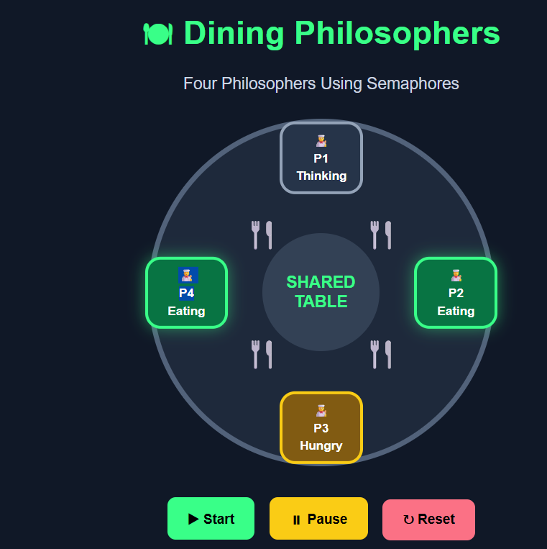
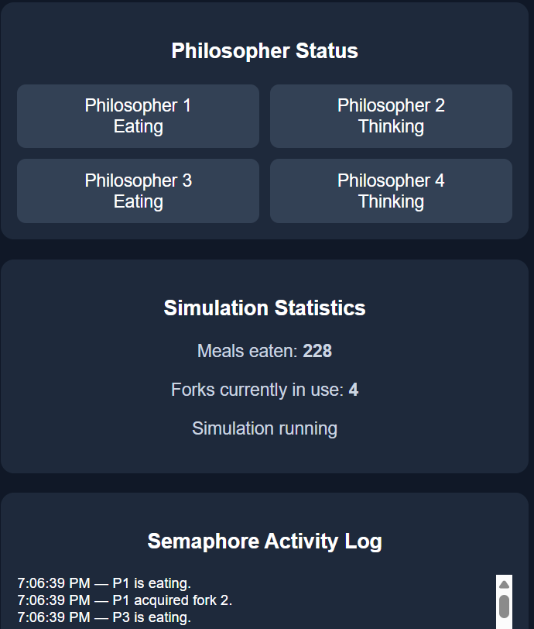
Dining Philosophers is a simulation that demonstrates four philosophers in transition from thinking state to hungry state and eating state using semaphores. The status panel indicates the work of each philosopher, whereas simulation statistics show the number of meals consumed and number of forks used.

2.Dining Philosopher Monitor based:
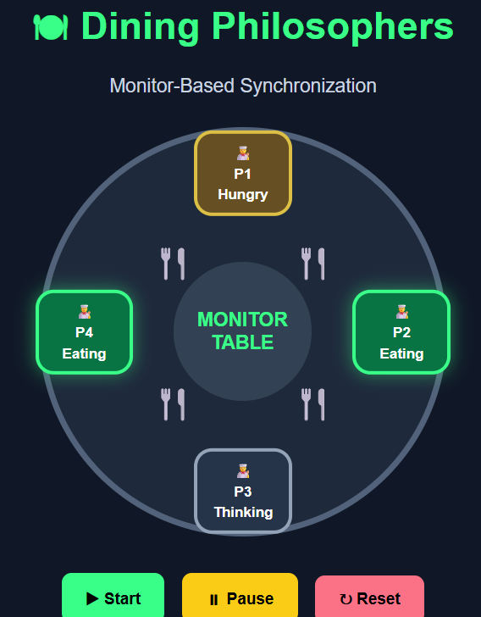
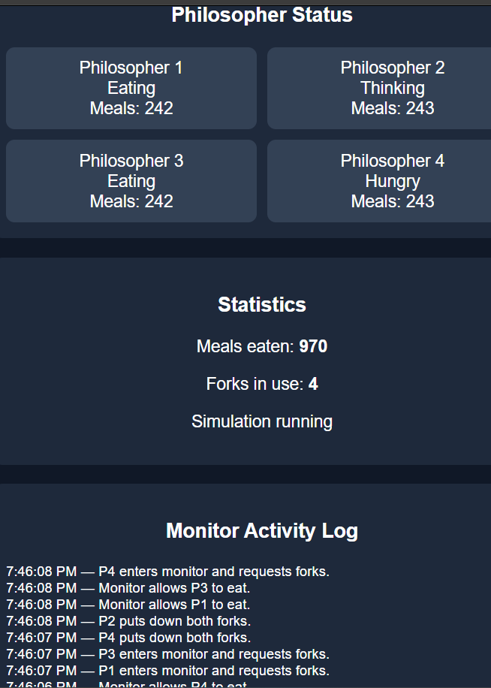
Dining philosophers simulation illustrates how monitors are used for synchronizing processes by creating philosopher objects that switch among THINKING, HUNGRY and EATING states. Monitor ensures mutual exclusion such that neighboring philosophers cannot eat concurrently. The statistics window shows the number of consumed meals and forks currently being used, whereas activities log shows monitor actions.

3.Reader Writer using Semaphore
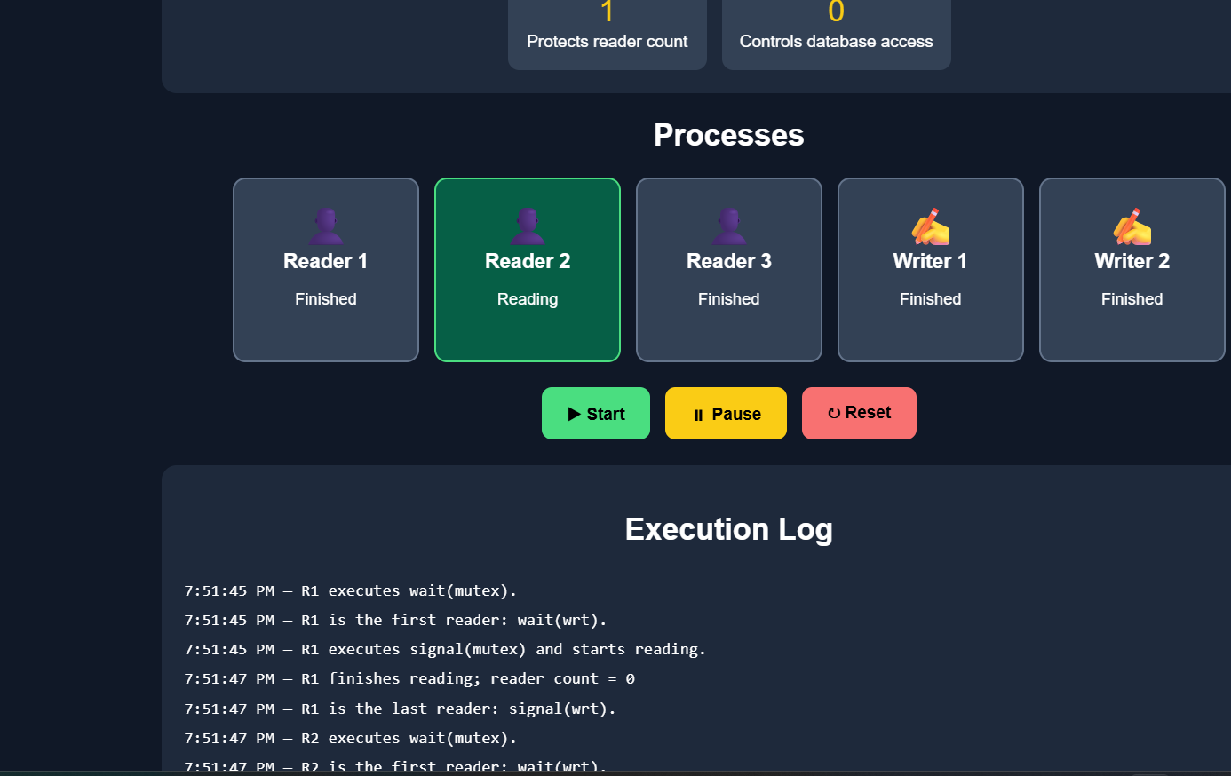

In order to simulate semaphores synchronization between the three readers and the two writers, we employ Reader-Writer simulation. Mutex semaphore ensures synchronization on the count variable of readers whereas Wrt semaphore manages writers' exclusive access to the shared
database. Processes tab represents status of individual threads, and Execution Log shows wait() and signal() methods calls.

4.Reader Writer using Monitor
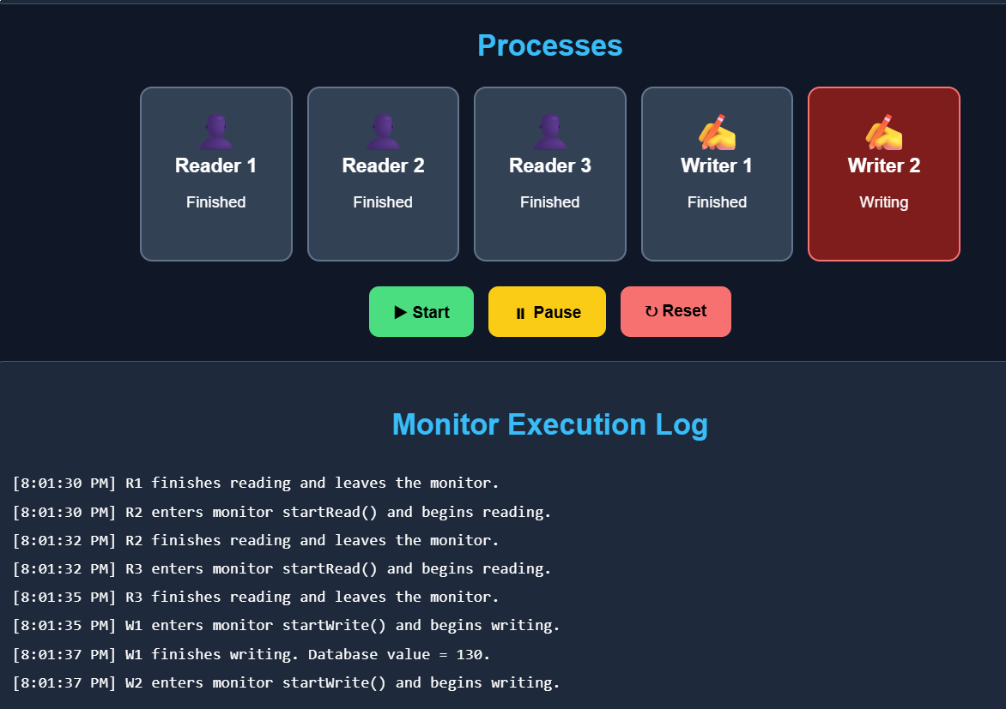
Simulation of the Reader Writer Problem using Monitor explains how synchronization between reader and writer threads occurs through the monitor. Monitor provides mutual exclusive access to a shared database where multiple readers can perform reading tasks simultaneously but only one writer performs write tasks at any moment of time. Panel shows threads' state whereas Execution Log shows monitor operations performed by threads.

AI Tool usage Summary:
In order to create solutions to readers-writers and four dining philosophers synchronization problems by implementing semaphores and monitors approaches, four Java programs were created. The process involved making use of an AI chatbot called ChatGPT. Initially, it was tasked with providing assignment specifications requiring students to write four Java programs that simulate readers-writers and four dining philosophers synchronization problems with semaphores and monitors solutions. Other prompts included improving HTML representations of program simulation, illustrating state transitions of processes and resource availability,
timeline events, and preparing statements of the problems, objective, brief descriptions of operation, contents of README files, and comparisons between approaches.
Verification: Both semaphore and monitor versions of the programs have been verified using the analysis of execution logs, transitions in processes' states, interaction with shared resources, and generated HTML simulation output. The simulation outputs have been analyzed to comprehend how synchronization ensures that no conflicts arise between two processes' simultaneous accesses to resources. Understanding of synchronization: Semaphore and monitor approaches have been contrasted to better comprehend the role played by locks, synchronization of Java methods, and the waiting mechanism for coordinating multiple threads. Event logging and execution sequence: Logs produced by concurrent threads might differ from the visual sequence since the former may occur after the latter. Consequently, the logs should be analyzed together with synchronization algorithms. Prevention of deadlock: In the semaphore solution, there exists a room semaphore that restricts the maximum number of philosophers who compete for forks concurrently. On the contrary, the monitor approach tests the states of neighboring philosophers before granting permission to any philosopher for starting to eat. Improved visualization: Simulation outputs that are generated as HTML documents facilitate visualization compared to console outputs.

Conclusion:
So, the Dining Philosophers Problem and the Reader Writer Problem have been successfully solved and simulated through semaphore and monitors in Java programming language. Such simulation gave us the chance to learn about process synchronization, mutual exclusion, and resource sharing in concurrent processes. Semaphore approach allows accessing the shared resources in a controlled manner through the use of signals, while the monitor approach uses shared methods and condition variables for synchronization. As a result, both approaches can help to avoid race conditions and maintain consistency of data.

References:
1.Dijkstra, Edsger W. EWD-1000 (PDF). E.W. Dijkstra Archive. Center for American History, University of Texas at Austin.
2. J. Díaz; I. Ramos (1981). Formalization of Programming Concepts: International Colloquium, Peniscola, Spain, April 19–25, 1981. Proceedings.
3. Hoare, C. A. R. (2004) [originally published in 1985 by Prentice Hall International]. "Communicating Sequential Processes" .
4. Tanenbaum, Andrew S. (2006), Operating Systems - Design and Implementation, 3rd edition [Chapter: 2.3.1 The Dining Philosophers Problem], Pearson Education, Inc.
5. Stallings, William (2018). Operating systems : internals and design principles (9th ed.). Harlow, Essex, England
6. Chandy, K.M.; Misra, J. (1984). The Drinking Philosophers Problem. ACM Transactions on Programming Languages and Systems.

=================== Thank you ===============================

